Lecture 3.2.2
Planar Graph
Course outcome to be covered:
CO3: Apply and recognized about the Graph Theory

1.1 Topic Objectives:
- To introduce with planar graph
- To understand the concepts of various properties of planar graph

1.2 Prerequisite
Consider and electronic circuit having several nodes with connections between them. Is it possible to print that none of the connections cross each other i.e they do not overlap or intersect?
This question can be answered if we know about planarity of graphs
1.3Introduction:
Planar graphs originated with the studies of polytopes and of maps. The (edges) of a three dimensional polytope provide a planar graph. We obtain a planar graph from a map by representing countries by vertices, and placing edges between countries that touch each other. Assuming each country is contiguous, this gives a planar graph. While planar graphs were introduced for practical reasons, they posess many remarkable mathematical properties.
This is one reason we will study them. A more practical reason for studying planar graphs is that they, and their relatives, appear in many practical applications. The study of two-dimensional images often results in problems related to planar graphs, as does the solution of many problems on the two-dimensional surface of our earth. Many natural three-dimensional graphs arise in scientific and engineering problems. These often come from well-shaped meshes, which share many properties with planar graphs.

1.4 Definition of Planar Graph:
A graph is said to be planar if it can be drawn in a plane so that no edge cross. Such a drawing is called a planar representation of the graph
Example: The graph shown in fig. is planar graph.

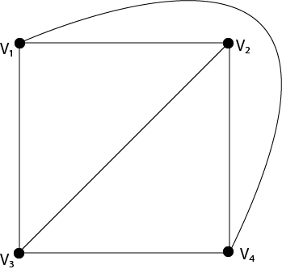
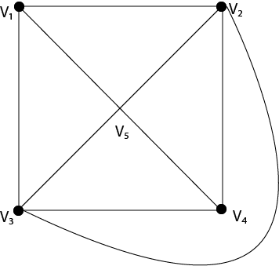
1.4 Region of a Graph:
Consider a planar graph G=(V,E).A region is defined to be an area of the plane that is bounded by edges and cannot be further subdivided. A planar graph divides the plans into one or more regions. One of these regions will be infinite.
1.4.1 Finite Region:
If the area of the region is finite, then that region is called a finite region.
1.4.2 Infinite Region:
If the area of the region is infinite, that region is called a infinite region. A planar graph has only one infinite region.
1.5 Example:
Consider the graph shown in Fig. Determine the number of regions, finite regions and an infinite region.
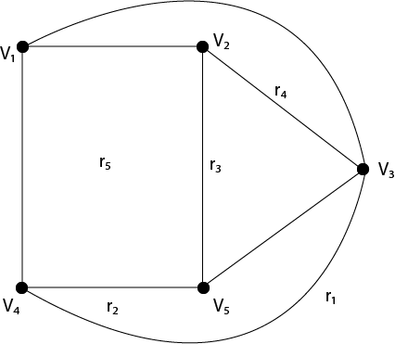
Solution: There are five regions in the above graph, i.e. r₁,r₂,r₃,r₄,r₅.
There are four finite regions in the graph, i.e., r₂,r₃,r₄, r₅.
There is only one finite region, i.e., r₁

1.6 Properties of Planar Graphs:

- If a connected planar graph G has e edges and r regions, then r ≤2/3e.
- If a connected planar graph G has e edges, v vertices, and r regions, then v- e+ r=2.
- If a connected planar graph G has e edges and v vertices, then 3v-e≥6.
- A complete graph K _{n} is a planar if and only if n<5.
- A complete bipartite graph K _{mn} is planar if and only if m<3 or n>3.
Example:
Prove that complete graph K₄ is planar.
Solution: The complete graph K₄ contains 4 vertices and 6 edges.
We know that for a connected planar graph 3v-e≥6.Hence for K₄, we have 3x4-6=6 which satisfies the property (3).
Thus K₄ is a planar graph.
Hence Proved.

1.7 Non-Planar Graph:
A graph is said to be non-planar if it cannot be drawn in a plane so that no edge cross.
Example: The graphs shown in fig are non-planar graphs.
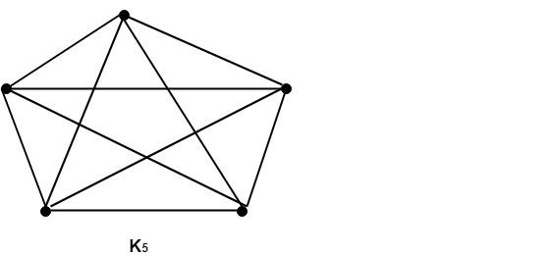
These graphs cannot be drawn in a plane so that no edges cross hence they are non-planar graphs.

Properties of Non-Planar Graphs:
A graph is non-planar if and only if it contains a subgraph homeomorphic to K₅ or K_{3,3}
Example1: Show that K₅ is non-planar.
Solution: The complete graph K₅ contains 5 vertices and 10 edges.
Now, for a connected planar graph 3v-e≥6.
Hence, for K₅, we have 3 x 5-10=5 (which does not satisfy property 3 because it must be greater than or equal to 6).
Thus, K₅ is a non-planar graph.
Example2: Show that the graphs shown in fig are non-planar by finding a sub graph homeomorphic to K₅ or K_{3,3}.
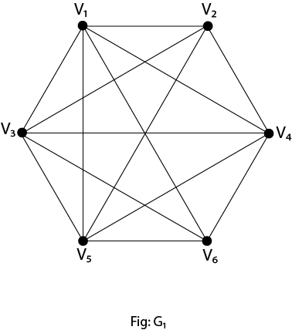
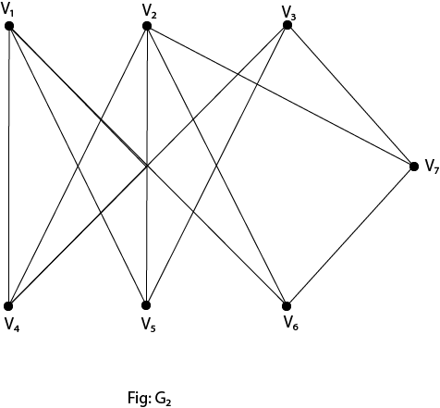

Solution: If we remove the edges (V₁,V₄),(V₃,V₄)and (V₅,V₄) the graph G₁,becomes homeomorphic to K₅.Hence it is non-planar.
If we remove the edge (V_{2,}V₇) the graph G₂ becomes homeomorphic to K_{3,3}.
Hence it is a non-planar.
Example 3: Is the hypercube planar?
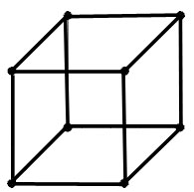
Solution: Yes, is planar. Its planar representation-
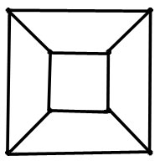

1.8 Some Areas of Application
- designing and structuring complex radio electronic circuits,
- railway maps,
- planetary gearbox
- Chemical molecules.
Practice Questions
  - Is it possible for a graph with 10 vertices and edges to be a connected planar graph? Explain
  - Prove that any planar graph must have a vertex of degree 5 or less.
FAQ
Q.1 What is the dual of a graph?
Ans: In the mathematical discipline of graph theory, the dual graph of a plane graph G is a graph that has a vertex for each face of G. The dual graph has an edge whenever two faces of G are separated from each other by an edge, and a self-loop when the same face appears on both sides of an edge.

Q.2 Are all bipartite graphs planar?
Ans: Cycle graphs with an even number of vertices are bipartite. Every planar graph whose faces all have even length is bipartite. Special cases of this are grid graphs and square graphs, in which every inner face consists of 4 edges and every inner vertex has four or more neighbors.
Summary
In this lecture, we have discussed about
- What is planar Graph
- Define region of a graph
- Non Planar graph
- Properties of planar Graph
- Examples related to planar graph

REFERENCES
Books
[1] Elements of Discrete Mathematics, (Second Edition) C. L. Liu, McGraw Hill, New Delhi, 2017
[2] G. Ronald, Knuth, Donald and Patashik Oren, concrete Mathematics: A Foundation for Computer Science", Addison-Wesley.
Websites
[1]https://www.geeksforgeeks.org/engineering-mathematics-tutorials/
[2] https://www.javatpoint.com/planar-and-non-planar-graphs
Courses
[1] https://www.coursera.org/specializations/discrete-mathematics
[2]https://www.classcentral.com/course/swayam-discrete-mathematics-12929
Video Links
[1] https://www.youtube.com/watch?v=rK45E_WJRE4
[2] https://youtu.be/ETtXKpfBWNI

